Insert School Logo

Semester Two

Examination 2018

Question/Answer booklet

MATHEMATICS
SPECIALIST UNITS 3 & 4

Section One:
Calculator-free

Student Name: _____________________________________
Teacher’s Name: _____________________________________

Time allowed for this section
Reading time before commencing work: five minutes
Working time for paper: fifty minutes

Material required/recommended for this section

To be provided by the supervisor
This Question/Answer booklet
Formula Sheet

To be provided by the candidate
Standard items: pens (blue/black preferred), pencils (including coloured), sharpener, correction tape/fluid, erasers, ruler, highlighters

Special Items: nil

Important note to candidates
No other items may be taken into the examination room. It is your responsibility to ensure that you do not have any unauthorised notes or other items of a non-personal nature in the examination room. If you have any unauthorised material with you, hand it to the supervisor before reading any further.

Structure of this paper

 | Number of questions available | Number of questions to be attempted | Working time (minutes) | Marks available | Percentage of exam
Section One  Calculator—free | 7 | 7 | 50 | 50 | 35
Section Two  Calculator—assumed | 10 | 10 | 100 | 100 | 65
 |  |  |  |  | 100

Instructions to candidates

- The rules for the conduct of Western Australian external examinations are detailed in the
Year 12 Information Handbook 2018. Sitting this examination implies that you agree to abide by these rules.

- Answer the questions according to the following instructions.

Show all your working clearly. Your working should be in sufficient detail to allow your
answers to be checked readily and for marks to be awarded for reasoning. Incorrect answers given without supporting reasoning cannot be allocated any marks. For any question or part question worth more than two marks, valid working or justification is required to receive full marks. If you repeat an answer to any question, ensure that you cancel the answer you do not wish to have marked.

It is recommended that you do not use pencil, except in diagrams.

- You must be careful to confine your responses to the specific questions asked and to follow any instructions that are specific to a particular question.

- Spare pages are included at the end of this booklet. They can be used for planning your responses and/or as additional space if required to continue an answer.
- Planning: If you use the spare pages for planning, indicate this clearly at the top of the page.
- Continuing an answer: If you need to use the space to continue an answer, indicate in the original answer space where the answer is continued, i.e. give the page number. Fill in the number of the question that you are continuing to answer at the top of the page.

- The Formula Sheet is not handed in with your Question/Answer Booklet.

Section One: Calculator–free 35% (50 marks)

This section has seven (7) questions. Attempt all questions. Write your answers in the spaces provided.
Spare pages are included at the end of this booklet. They can be used for planning your responses and/or as additional space if required to continue an answer.

Working time: 50 minutes

Question 1 (5 marks)

Given the three planes represented by the equations

(a) determine the values of such that the intersection of the planes
has no solution. (1 mark)

(b) find the intersection point of the three planes if (4 marks)

Question 2 (5 marks)

(a) The graph of the function is shown below.
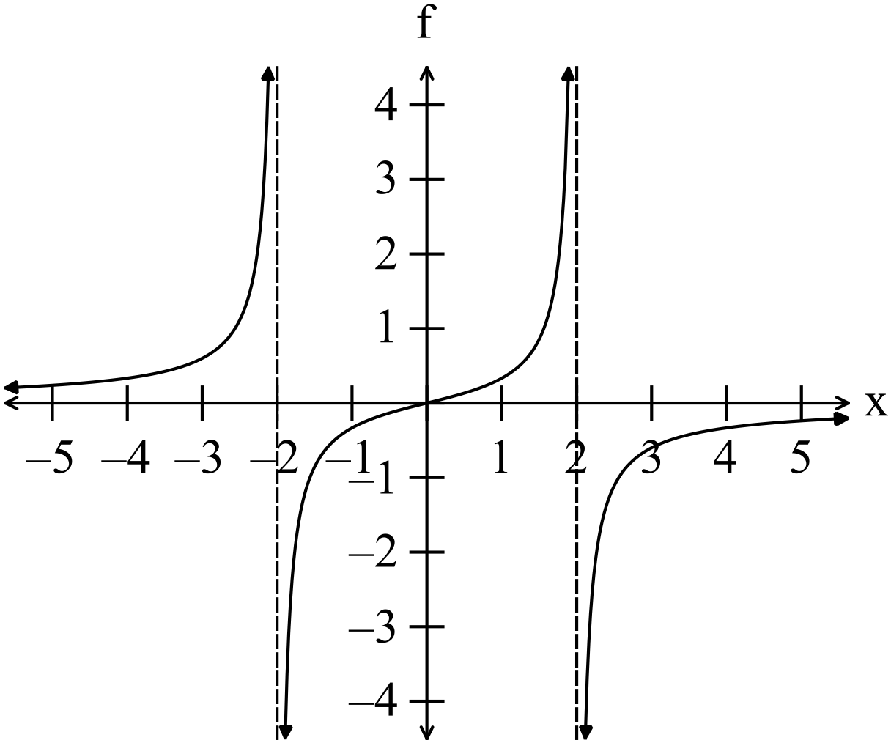

Sketch the function on the set of axes below. (2 marks)
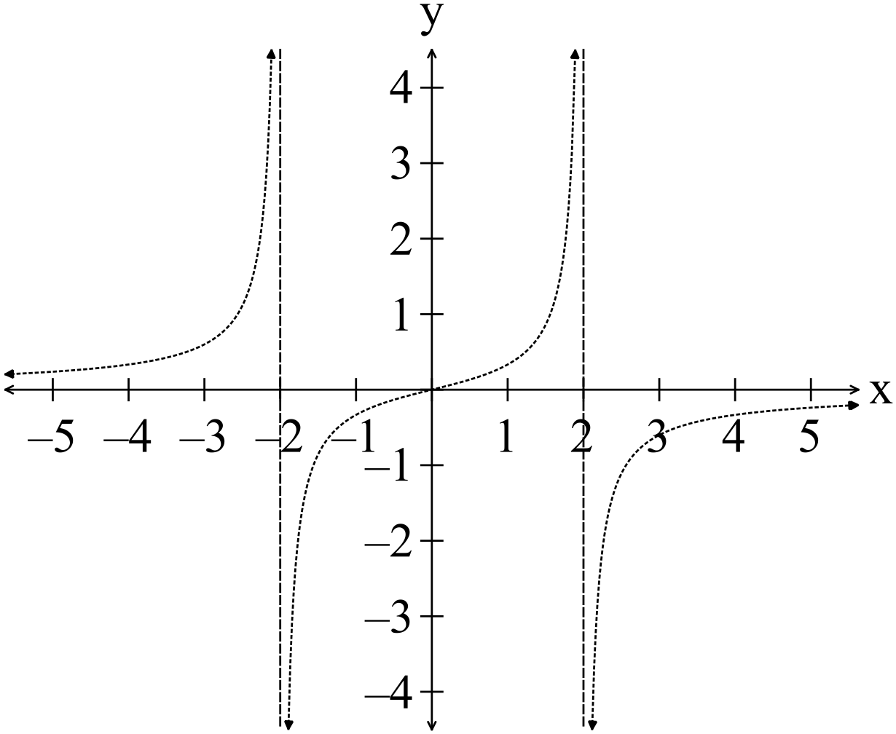

(b) Solve for given . (3 marks)

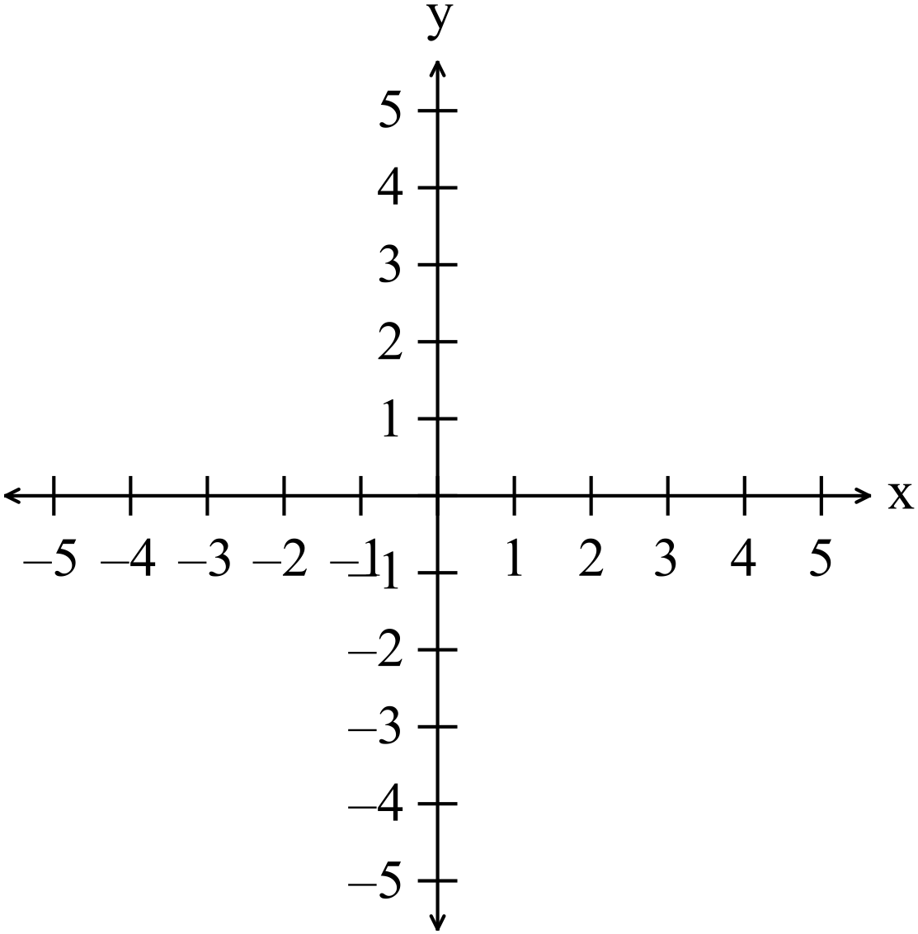
Question 3 (8 marks)

(a) Consider the functions and .
(i) Write down the domain of f such that the function is exists. (3 marks)

(ii) Determine whether or not the function is a one to one function.
Explain your answer. (2 marks)

(b) Find the equation of the inverse of , restricting the domain appropriately so that the inverse exists. (3 marks)

Question 4 (12 marks)

(a) Given the quadratic equation determine the value(s) of b such that the
equation has complex roots. (1 mark)

(b) Solve the equation (4 marks)

(c) Two roots of a cubic equation with real coefficients are plotted on the Argand diagram below.

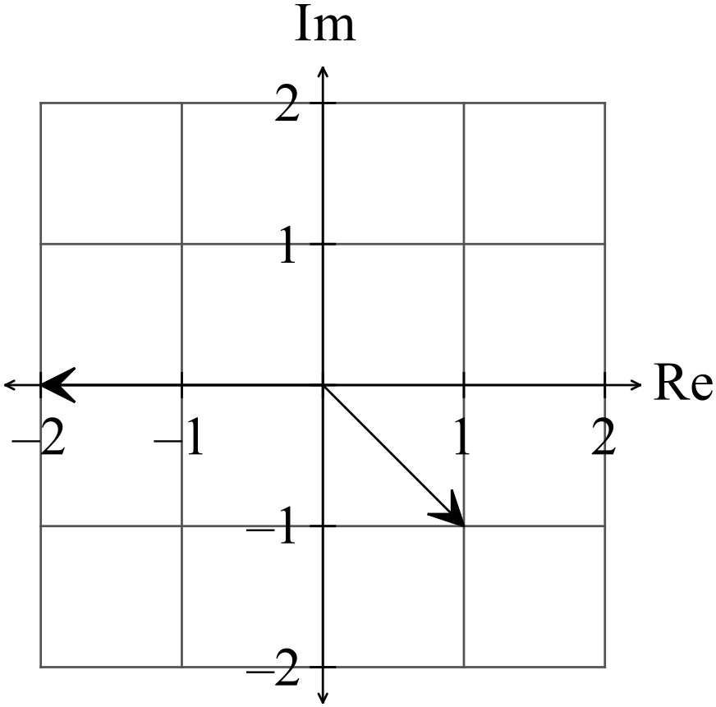

(i) Plot the third root on the diagram above. (1 mark)

(ii) Determine the cubic equation. (2 marks)

(d) Simplify to form. (4 marks)

Question 5 (4 marks)

(a) Given the equation , plot the roots on the diagram below. (1 mark)

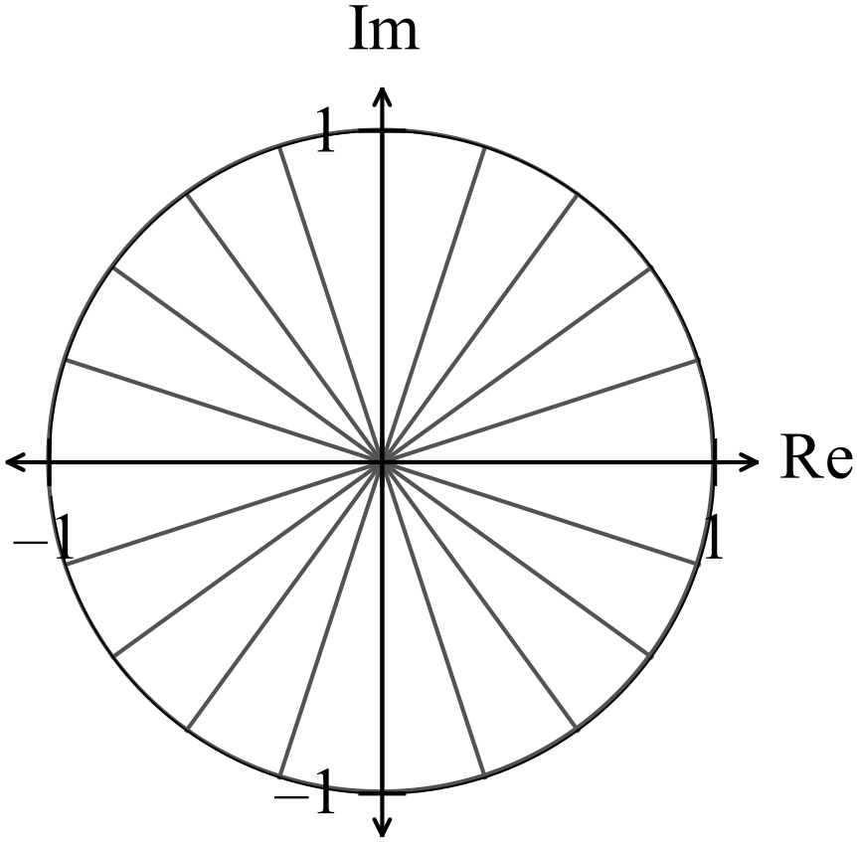

(b) Show how to determine the roots algebraically. (3 marks)

Question 6 (4 marks)

(a) Find the expression for given the relationship shown graphed below.
(3 marks)
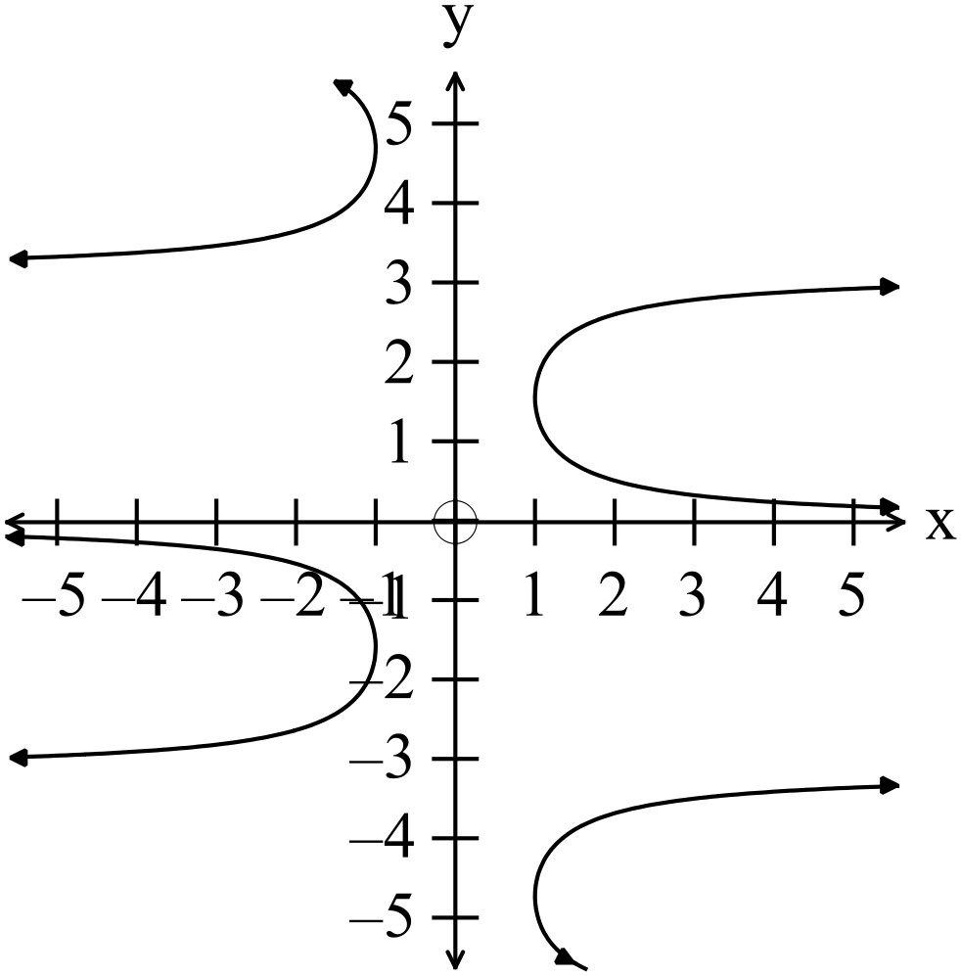

(b) Hence find the coordinates of the point on the curve in quadrant one where is not defined.
(1 mark)

Question 7 (12 marks)
(a) Evaluate the following definite integrals exactly.
(i) (3 marks)

(ii) (4 marks)

(b) Determine (5 marks)
Hint: Consider

End of Questions
Additional working space

Question number(s): ……………………

Additional working space

Question number(s): ……………………

